Strand B: Silvia Santamaria Buil 8159

System Summary:

* The front-end of the application will be made using pygame to create a graphical user interface for data to be input.
* The data that the user inputs will then be stored in a relational database consisting of a variety of tables for different groups of data so that it is more easily understandable.
* More sensitive data will be stored in a hash table, such as passwords, which will be used to access the users data whenever a new user uses the system.

Group A skills:

* Hash Tables and Hashing – used for the storage of sensitive data and for easily switching between accounts
* Cross table parameterised SQL and aggregate functions – used to process data received from GUI and stored in relational database
* Relational Databases – where all data will be stored, will consist of a variety of tables and databases such that all data is well organised and easily accessible
* Complex User Defined Algorithms (extension) – used to generate lessons so that users can learn in a more efficient manner

Data Structures:

* I will be using tables to make up the database where all the different user’s data will be stored. There will be separate tables for teacher accounts and student accounts.
* A table will also be used to create the hash tables where data will be input into a hashing algorithm in order to find the correct index in the table for the data to be stored.
* Trees may be used to create the model that will generate lessons for the user.

Prototype:

The home screen may look like the image on the left, with each of the icons acting as buttons that will either lead the user to other screens, or will dynamically generate a pop up with information on the lesson.

The log in screen may look like the images below, with each of the greyed out boxes acting as text boxes the user can input information into, and the coloured boxes acting as buttons leading the user to other pages.

The mascot will be a snake, as decided by the feedback from clients and as inspired by the python language.

Gantt Chart:

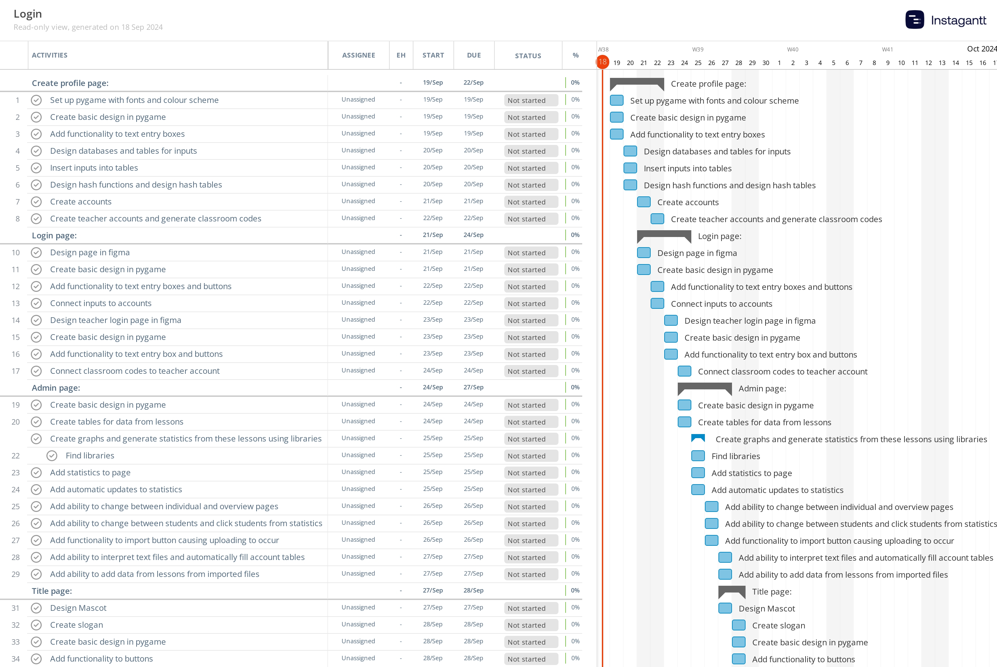

Overview using diagrams:

To help the design process, I used a top-down design approach to create a hierarchy diagram depicting everything I believe I will need to create during my app’s development. This decomposition will make it easier to tackle individual parts of my app as I can make separate modules/functions for each box. Blue boxes contain UI modules, Green boxes contain Account modules and Purple boxes contain Lesson modules. Orange boxes contain Grade A criteria.

Creating an account/logging in:

Mock up of screens:

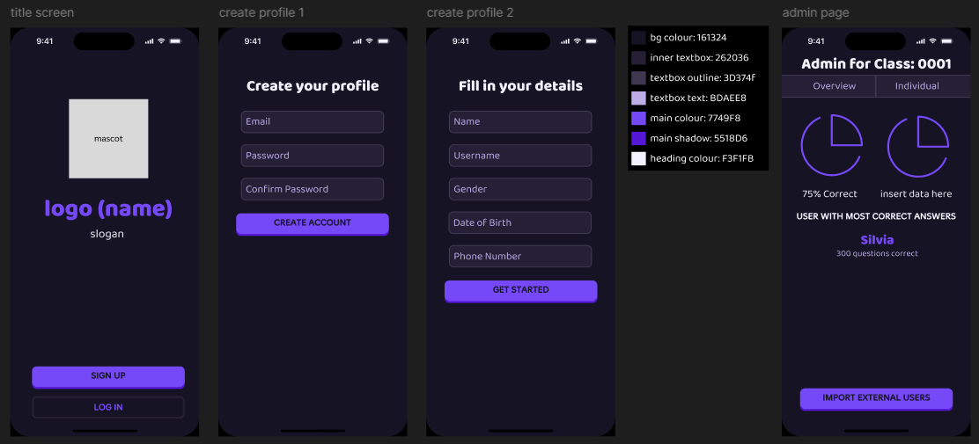[Click to see with interactive buttons](https://www.figma.com/proto/mPUH4ABYZcJAv8eUdPrpPB/login-screen-mock-up?node-id=19-134&t=WgDLDx3R7Ig9dAw0-1&scaling=scale-down&content-scaling=fixed&page-id=0%3A1&starting-point-node-id=19%3A134)

Current Code:

Currently, the login screen consists of 2 textboxes where the user should be able to input their email and password. Currently, the boxes are not functioning, however, after adding all the other design features, like the remaining box for confirming the password and the button and header, the boxes will be given functionality, which will allow for the user to type their data inside. The boxes are currently pygame rectangles, with text written on top in one of the default fonts available. However, I intend to install and use ‘Baloo’, ‘Baloo 2’, and ‘Merge One’ as the fonts for the login screen, and will add these and format everything correctly as the project continues. A black rectangular object with a gold border
All the design is in the correct colour scheme currently; however the text boxes should have a lighter outline.